**IDEATION PHASE**

|  |  |
| --- | --- |
| Team ID | NM2023TMID02667 |
| Project Name | How to add google analytics to a website |
| Date | 3 November 2023 |

**Define the problem statement**

Our website currently lacks a comprehensive analytics solution, making it challenging to gather essential data about user behavior and website performance. To address this issue, we need to integrate Google Analytics into our website to track and analyze user interactions, monitor traffic sources, and measure the effectiveness of our online presence. This will enable us to make data-driven decisions, enhance user experience, and optimize our digital marketing efforts.

**Empathize and Discover**

. Empathize: Understand the problem or need deeply by putting yourself in the shoes of the people you're designing for. This might involve interviews, surveys, and observations to gather insights.

Discover: Research existing solutions, market trends, and competitors to identify gaps and opportunities. Analyze data, conduct brainstorming sessions, and collaborate with diverse teams to expand your knowledge.

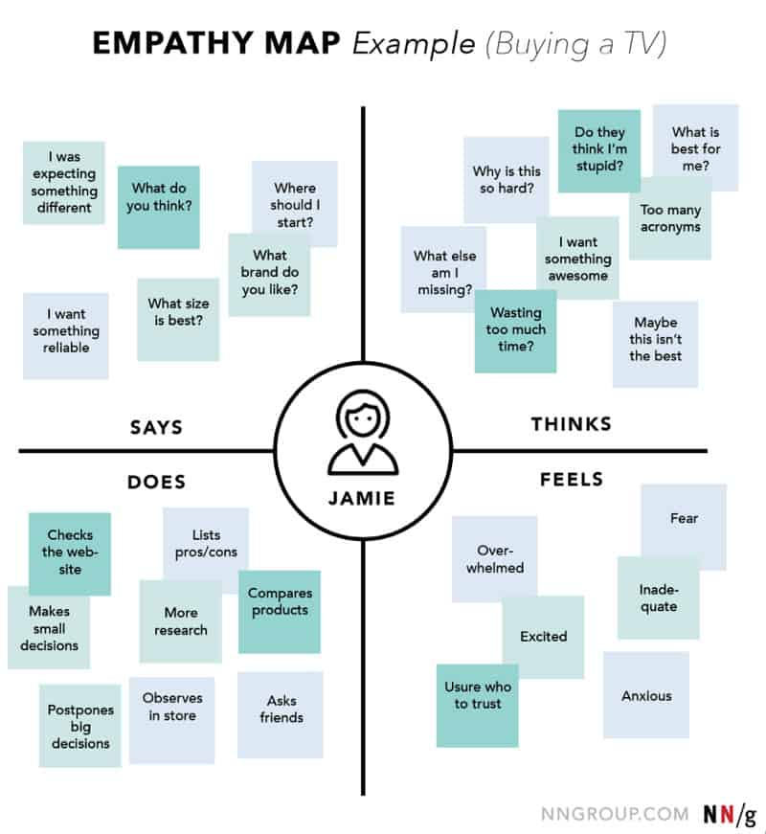

**Brainstrom and Prioritize Ideas**

Prioritize Ideas:Rank ideas based on their potential to address the problem or achieve the goal.

Create a shortlist of the most promising ideas. Brainstorming Sessions: Gather a group of people and encourage them to freely share their thoughts and ideas on a specific topic.

